Triangle Industrial  City Improvement District NPC  Company Registration no: 2005/029020/08  VAT Registration no: 4310248457  Unit 1 | Cnr Electron & Uranium Street| Stikland  Tel : 021-949 4564  www.trianglefarmcid.co.za | 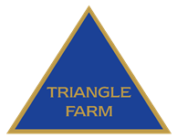CITY IMPROVEMENT DISTRICT

MANAGER / CHAIRMAN’S REPORT

2017/2018

COMPILED BY: LYNETTE VAN LILL
MANAGER
TRIANGLE INDUSTRIAL CITY IMPROVEMENT DISTRICT NPC
JULY 2018

INDEX

- INTRODUCTION

- MISSION / VISION STATEMENTS

- ACTIVITIES

- PROJECTS / ACHIEVEMENTS

- MEETINGS

- FINANCIAL

- NEW MEMBERS / DIRECTORS

Triangle Industrial  City Improvement District NPC  Company Registration no: 2005/029020/08  VAT Registration no: 4310248457  Unit 1 | Cnr Electron & Uranium Street| Stikland  Tel : 021-949 4564  www.trianglefarmcid.co.za | CITY IMPROVEMENT DISTRICT

MANAGER / CHAIRMAN’S REPORT: 2017/2018

- INTRODUCTION

The Triangle Industrial City Improvement District (TICID) / Special Rating area (SRA)
continuously strives towards building confidence in the area as a safe, attractive and clean environment in which to conduct business with special attention paid to core responsibilities that encourages investment in the area, halt degeneration and promote economic growth/sustainable development.

The TICID provides services that are consistent with the City’s Integrated Development Plan (“IDP”) by providing top-up services to the City of Cape Town.

During the period 1 April 2009 to June 2018: -

- 42 arrests were made by the CID Security service provider
- 13 044 black bags were removed by the CID’s cleansing service
- 838 954 km was travelled in patrols by the CID security in the industrial area

The following were reported by the CID to the City of Cape Town:-

- 775 faulty street lights / damaged lamp poles
- 225 burst pipes / blocked drains
- 316 potholes

- MISSION / VISION STATEMENT

The CID has the following mission / vision statements:-

MISSION STATEMENT
To decrease waste and grime and eliminate crime in the Triangle Industrial area through effective security patrols and additional cleansing services and co-ordinating a project aimed at waste minimization.

VISION STATEMENT

Shall strive to develop and market a safe, secure, clean and attractive environment in which to conduct business.

- ACTIVITIES

The CID is managed by a Board of six Directors elected by its members. Services provided focused on safety and security, cleansing initiatives, urban management initiatives, social intervention and marketing.

The Triangle Industrial CID was involved in the following:-

- The CID was instrumental in the co-ordination of Safety and Security meetings that were attended by Management from GBS Security (CID’s Security service provider), SA Police, Traffic Services, Metro Police, Law Enforcement, and various role players aimed at securing the CID business environment. “Hot spot” areas were identified in order to address issues of concern.

- Provide an efficient Public Safety Security service with 24-hour vehicle patrols in the CID area.

- Due to the increase of crime, mostly robberies on the public open space and along the Metrorail reserve, theft out of motor vehicle, and burglaries, regular interaction / blitz operations were held incorporating SA Police Service, Traffic Services, Metro Police, and various sections of Specialized services i.e. Metal Theft Unit (MTU), Anti-Land Invasion, including members from various security companies.

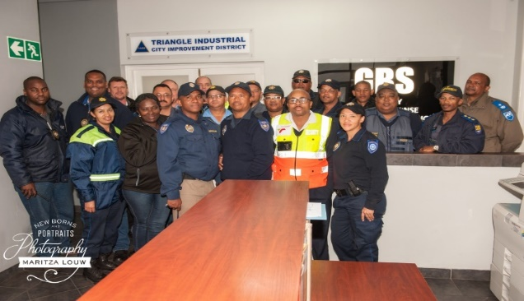

An article was placed in the 25 April 2018 edition of the Tyger Burger.

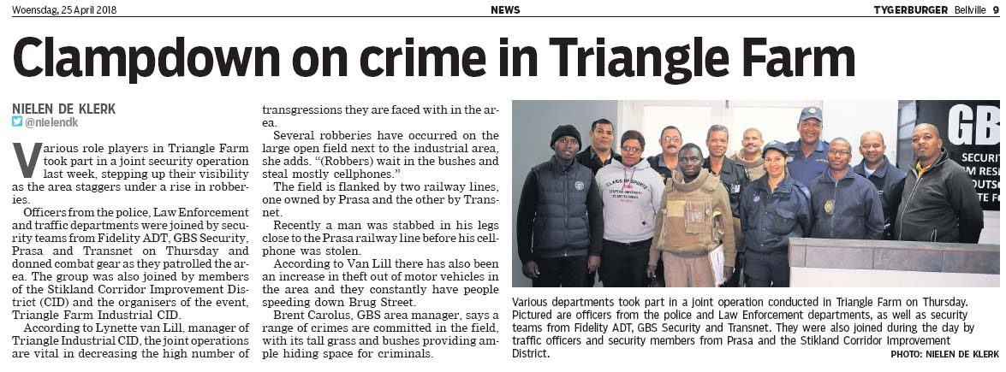

- The CID’s mobile trailer donated by DOCS, together with a Public Safety officer were used effectively and deployed daily in Uranium Street leading to the public open space. This hugely reduced the robberies and prevented people from entering and dumping on the public open space.

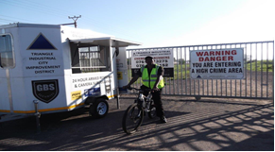

- The CID monitors vacant land belonging to the City of Cape Town and on the railway reserve reporting any informal structures.
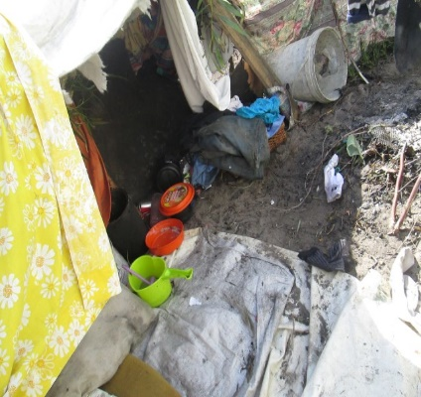
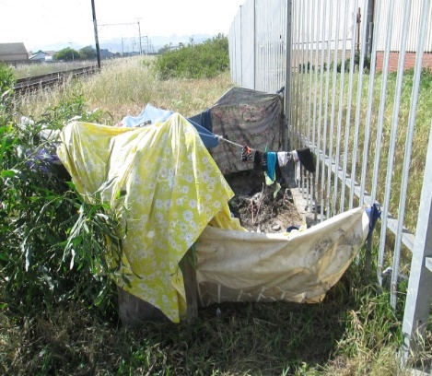

The City’s Anti-Land Invasion was awarded with the “CID Board Trophy” at the CID’s
Annual General Meeting held in November 2017 for their excellent service and prompt
response with the removal of makeshift structures on the public open space and along
the railway reserve.

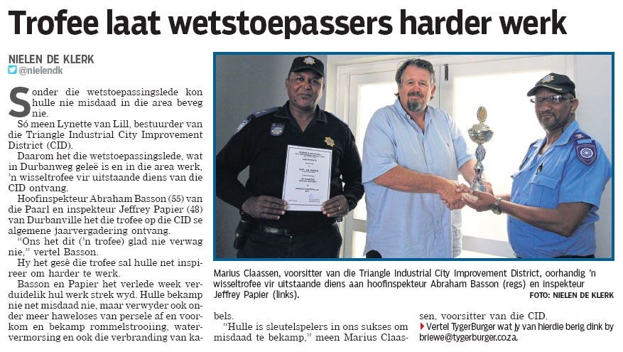

- Distribution of a weekly public safety update and newsletters pertaining to activities occurring in the SRA area.

- Regular updating of the CID’s website at www.trianglefarmcid.co.za incorporating a Home page, Projects, Awareness, Newsletters, and a Business directory of all the companies within the SRA.

- Recycling project to assist and uplift a neighboring school with the assistance of the business associates in the area. With the funds generated from this project blinds were installed at the school. This project will also reduce waste to our overloaded landfill sites.

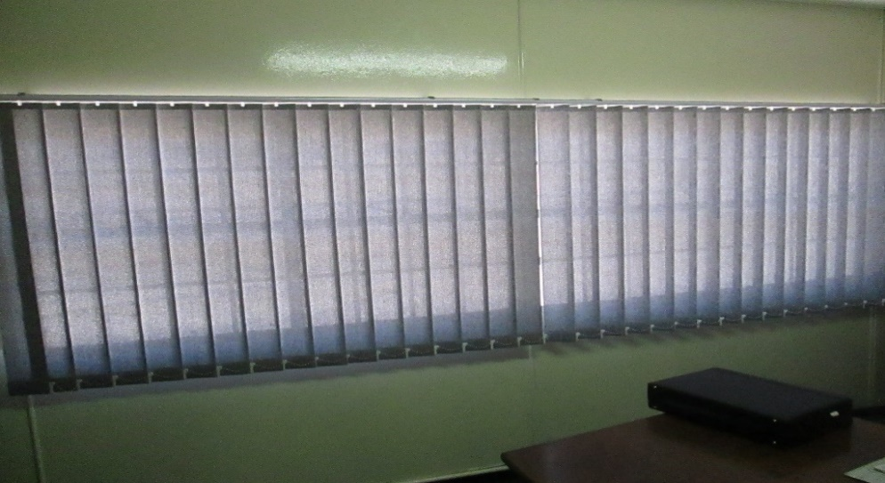

- Surveys were conducted daily with reports submitted to the City of Cape Town regarding defective street lights, damaged lamp poles/signage, missing/damaged drain covers, blocked drains, maintenance of road surfaces, placing and emptying of litter bins, road markings, road signs, etc.

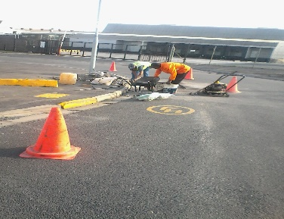
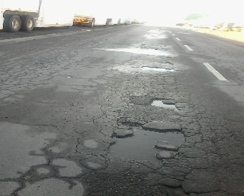
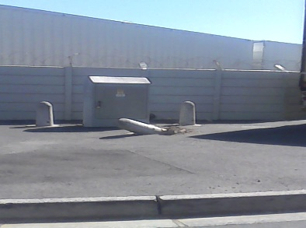

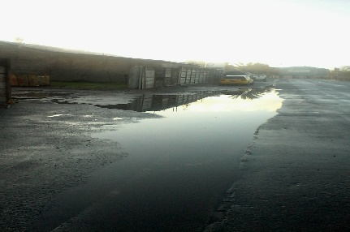
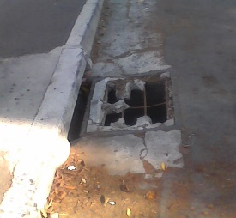
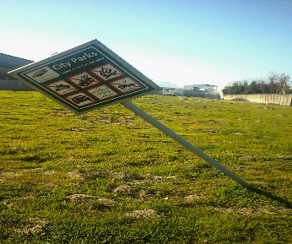

The Triangle Industrial CID plays a vital role in the effort to safe water.

Burst pipes and leaks detected in the area are reported with upmost importance to the
City of Cape Town who promptly responds to the leaks.

Water leak underground Repaired
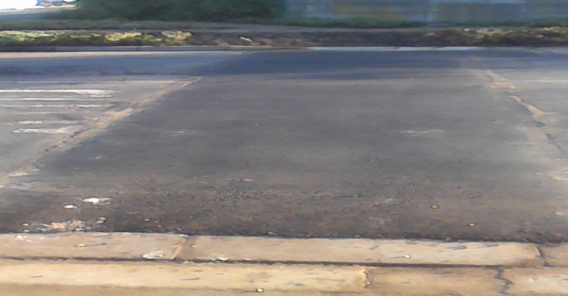
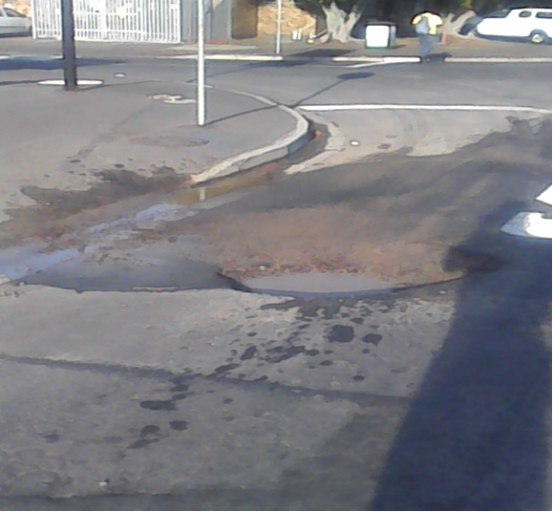

- The CID identifies the root causes of grime by conducting necessary surveys and identifying environmental design contributing to grime. A cleansing service is co- ordinated where two cleaners provide a daily “top-up” service to Council, including a garden service that cuts the grass monthly on the public open space and between businesses within the SRA.

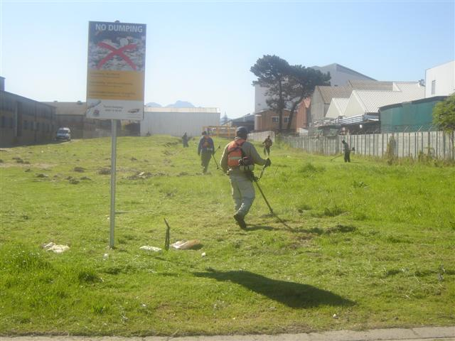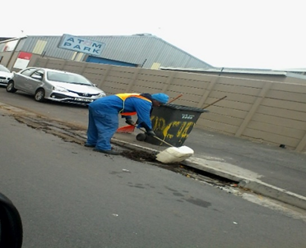
Garden service Cleaners

- Property and business owners are encouraged to keep their premises and street frontages clean. Competitions are held annually for neatest building, best garden and the most improved buildings.

4. PROJECTS / ACHIEVEMENTS

The following projects were successfully completed by the SRA:

* Root pruning

A request was submitted to City Parks due to roots causing damage to the pavement
in Uranium Street.

The root pruning and removal of three trees were completed in August 2017.

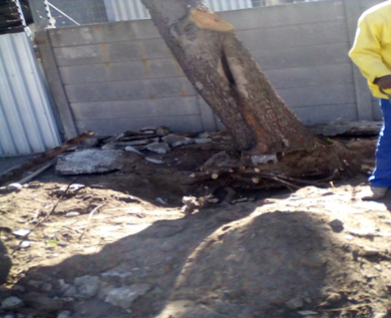
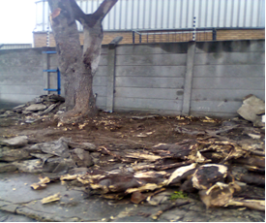

* Bollards

Due to vehicles entering and parking on the public open space (Erf 12862) at the
entrance of Electron Street a request was submitted to City Parks to enclose the
section with bollards.

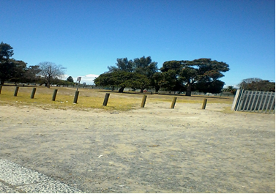
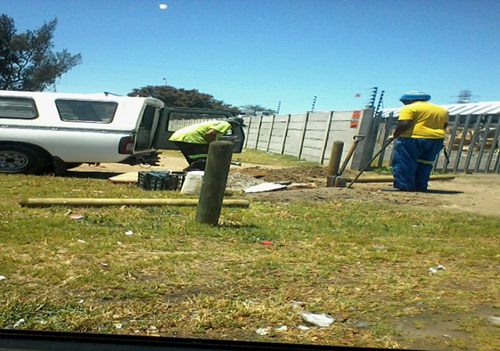

This was completed in November 2017.

* Refurbishment of Signage

The CID’s three signboards sponsored by Broll and API Property Group at the
entrance of Triangle Farm in Brug, Electron and Peter Barlow Road was refurbished
in February 2018.
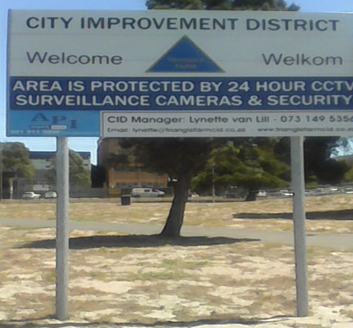
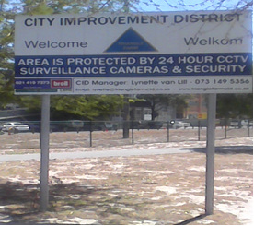

* Upgrading of landscaping

The two sections of landscaping on the corner of Brug and Molecule Street was
upgraded and completed in February 2018.
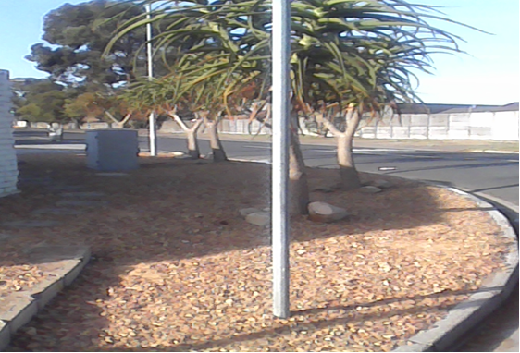
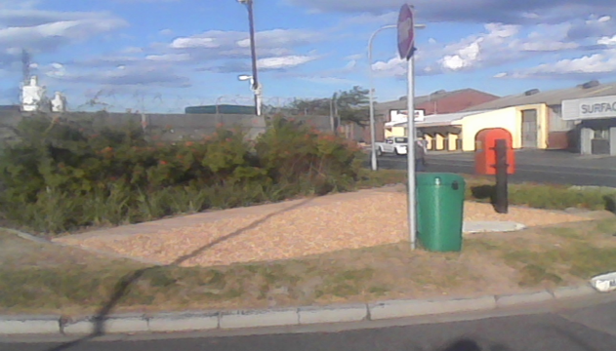

* Graffiti

Graffiti was noticed on exterior walls of business premises and on the vibracrete
wall in Uranium Street leading to the public open space and reported to Law
Enforcement.
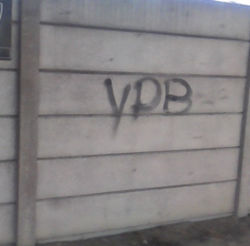
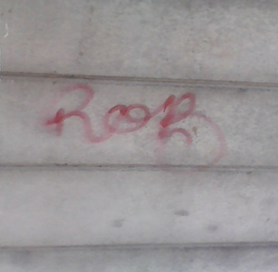
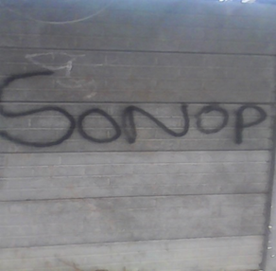

The graffiti was removed in March 2018.
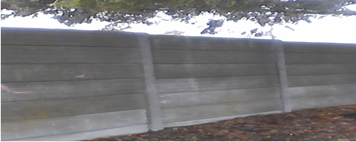

* Illegal dumping

Illegal dumping in the area was removed.

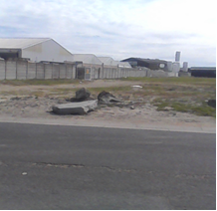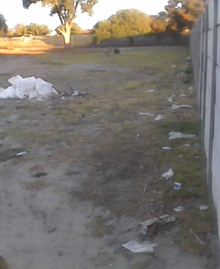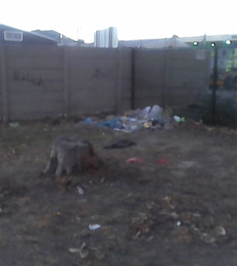

* Traffic congestion

The Triangle Industrial CID submitted a request to SPO Transport Network
Development regarding the traffic congestion in peak hour in Peter Barlow and
Electron Road.

After an investigation was completed, the City of Cape Town recommended a slip
road be built in Electron Street to assist vehicles exiting out of Electron Street, and
a slip road on the left-hand side in Peter Barlow at the intersection Pater Barlow and
Strand Street to ease the RHT movement delays.

Construction in progress: Electron Street February 2018
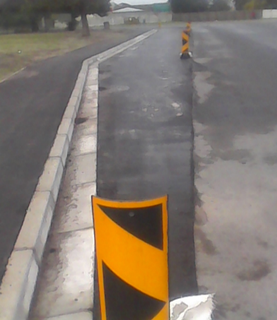
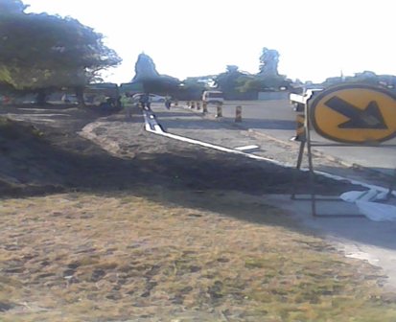
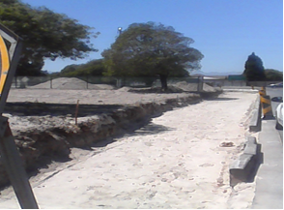

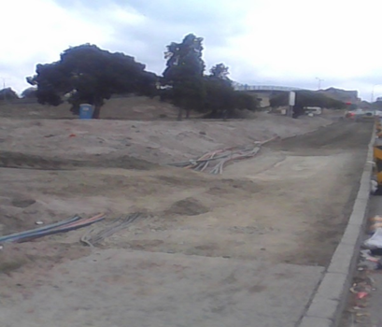
Construction in progress: Peter Barlow Road
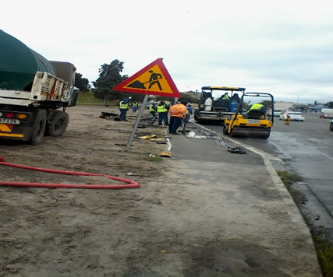

This was completed in June 2018.

Electron Street Peter Barlow Road
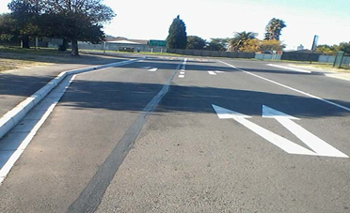
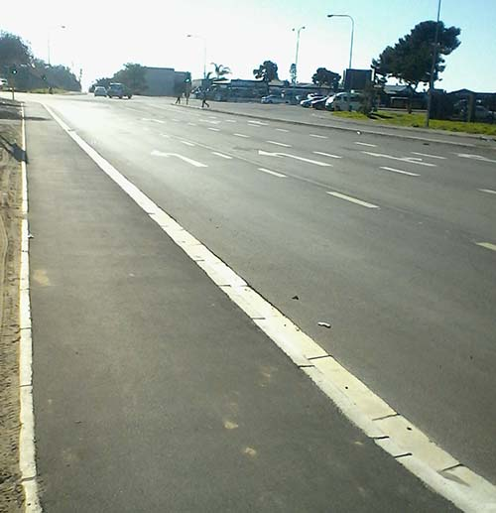

* Razor wire in Reactor / Uranium Street

Due to people bending the spikes to climb over the wall to enter the area, the
CID installed 324m concertina razor wire on top of the wall in Reactor Street and 3m
in Uranium Street. This was completed in June 2018.

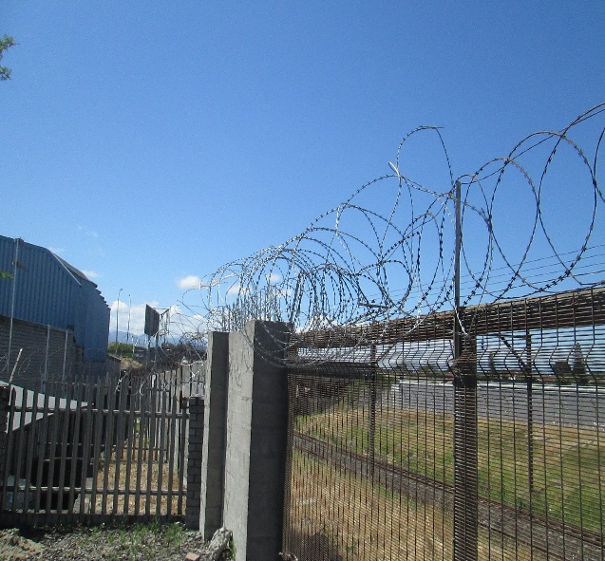
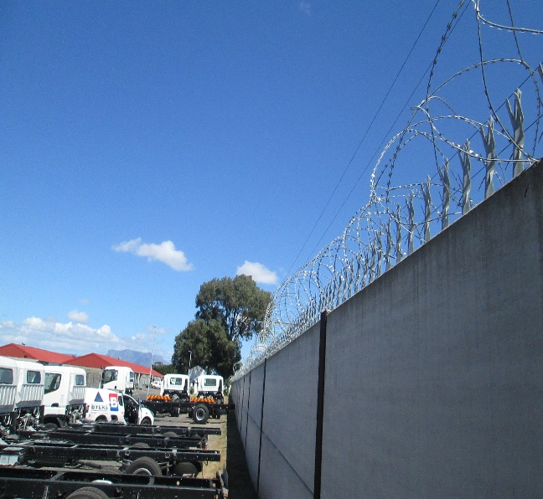
Reactor Street Uranium Street

The Triangle Industrial CID wishes to extend our most sincere appreciation to the
City of Cape Town’s Departments who had rendered excellent service to the CID.

5. MEETINGS

In addition to daily meetings with the CID’s Security service provider, the following
meetings also took place during 2017/2018: -

2017-07-04: Meeting with GBS Security
2017-07-05: CID Safety & Security Meeting
2017-07-12: Meeting with Fang to discuss the replacement of the two LPR CCTV
Cameras at the entrance
2017-07-12: Meeting with Mr. M. Julius from Air Pollution, City of Cape Town
2017-07-13: CID Board Meeting
2017-07-14: Meeting with Astrosec to discuss the CCTV monitoring
2017-07-14: Meeting with Supt. Phillips from Metro Police
2017-07-26: CID Forum Meeting
2017-07-28: CID Joint operation with Metro Police
2017-08-02: Meeting with GBS Security
2017-08-02: CID Safety & Security Meeting
2017-08-18: CID Joint operation with Metro Police and Law Enforcement
2017-08-24: CID Joint operation with various role players from SA Police Service,
Traffic Services, Law Enforcement, Security companies, etc.
2017-08-31: Meeting with Topfloor to discuss the wall on the public open space
2017-08-31: Meeting with GBS Security

2017-09-06: CID Safety & Security Meeting
2017-09-12: Area Based Delivery Meeting with Cllr. S. Mamkeli at Goodwood
Civic
2017-09-17: Meeting with Astrosec (CCTV monitoring) and Fang (CCTV
maintenance)
2017-09-15: Meeting with Fang to discuss proposal for CCTV cameras
2017-09-21: CID Board Meeting
2017-10-04: CID Safety & Security Meeting
2017-10-03: Site meeting with Mr. B. Jones (City Parks) to discuss the bush
clearing on the public open space
2017-10-24: CID Board Meeting
2017-11-01: CID Safety & Security Meeting
2017-11-14: Meeting with Mr. Billie and Mr. Damons from Water Works
2017-11-21: CID Annual General Meeting
2017-12-06: CID Safety & Security meeting
2017-12-12: Meeting with Media – TygerBurger
2017-12-15: CID Joint operation with various role players
2018-01-30: GBS Security Meeting
2018-01-31: Meeting with Mr. Engelbrecht (Metrorail) regarding damage to fence
2018-02-07: CID Safety & Security Meeting
2018-02-05: Meeting with CID Cleansing Service provider
2018-02-13: Meeting with Traffic Engineering Consultant to discuss parking,
Bus Stop signage and Pedestrian crossing in Bridge Street.
2018-02-15: CID Board Meeting
2018-02-19: Meeting at Parow Civic Council Chambers to discuss the drought
situation
2018-02-28: Meeting with CID’s Cleansing Service provider to discuss the
upgrading of the current landscaping
2018-03-06: Meeting with the Board to discuss the Security Server provider
contract
2018-03-07: CID Safety & Security Meeting
2018-03-15: Meeting with Board to discuss the new Security Service provider
2018-04-04: CID Safety & Security Meeting
2018-04-06: Meeting with Afriwire & Steel to discuss installation of razor wire
on top of wall in Reactor and Uranium Street
2018-04-10: Site Meeting with Metrorail to discuss the repairs of fence and bush
clearing along the Metrorail reserve
2018-04-12: CID Board Meeting
2018-04-19: CID Joint operation
2018-05-09: CID Safety & Security Meeting
2018-05-31: Area Based Management meeting at Goodwood Civic
2018-06-05: Site Meeting with TDA Transport to discuss the stormwater drains/
channels
2018-06-06: Meeting with Byers Security to discuss the CCTV cameras
2018-06-08: Site meeting with Metrorail contractor regarding the bush clearing
2018-06-21: Meeting with the Board and new Security Service provider.

6. FINANCIAL

The Triangle Industrial City Improvement District NPC currently finds itself in a
sound financial position.

In accordance with the Finance Agreement, the City pays over 97% of the annual
budget to the CID in 1/12th instalments and retains 3% as a provision for bad debts.

Accordingly, the City paid over R2,056,720.10 and retained R63,609.90 for the
2017/18 financial year. Retention of R132,641.67 was refunded to the Triangle
Industrial City Improvement District in 2017/18.

7. NEW MEMBERS / DIRECTORS

During 2017/18 the CID had a total of six directors. Four directors resigned
during 2017/18 and three new directors were co-opted in 2018.

During 2017/18 one member resigned as a member as she ceased to be a property
owner in the CID area. One application for membership were received. The total
number of members to date is 26.

All directors and existing members are thanked for their commitment towards
the CID’s endeavors.

L. van Lill
Manager
Triangle Industrial City Improvement District NPC
July 2018

