Triangle Industrial  City Improvement District NPC  Company Registration no: 2005/029020/08  VAT Registration no: 4310248457  Busaf Park No. 2 | 21 Brug Street| Stikland  Tel : 021-949 2800  www.trianglefarmcid.co.za | 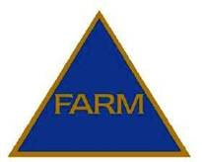

MANAGER / CHAIRMAN’S REPORT

2016/2017

COMPILED BY: LYNETTE VAN LILL
MANAGER
TRIANGLE INDUSTRIAL CITY IMPROVEMENT DISTRICT NPC
JULY 2017

INDEX

- INTRODUCTION

- MISSION / VISION STATEMENTS

- ACTIVITIES

- PROJECTS / ACHIEVEMENTS

- MEETINGS

- FINANCIAL

- NEW MEMBERS / DIRECTORS

Triangle Industrial
City Improvement District NPC
Company Registration no: 2005/029020/08
VAT Registration no: 4310248457
Busaf Park No. 2 | 21 Brug Street| Stikland
Tel : 021-949 2800
www.trianglefarmcid.co.za

MANAGER / CHAIRMAN’S REPORT: 2016/2017

- INTRODUCTION

The Triangle Industrial City Improvement District (CID) / Special Rating area (SRA)
continuously strives towards building confidence in the area as a safe, attractive and clean environment in which to conduct business with special attention paid to core responsibilities that encourages investment in the area, halt degeneration and promote economic growth/sustainable development.

The CID provides services that are consistent with the City’s Integrated Development Plan (“IDP”) by providing top-up services to the City of Cape Town.

During the period 1 April 2009 to June 2017:-

- 11 812 black bags of litter were removed by the CID’s cleansing service
- 738 606km were travelled in patrols by the CID’s Security provider in the industrial area

The following were reported by the CID to the City of Cape Town:-

- 633 Faulty street lights / damaged lamp poles
- 182 Burst pipes / blocked drains
- 252 Potholes

- MISSION / VISION STATEMENT

The CID has the following mission / vision statements:-

MISSION STATEMENT
To decrease waste and grime and eliminate crime in the Triangle Industrial area through effective security patrols and additional cleansing services and co-ordinating a project aimed at waste minimization.

VISION STATEMENT

Shall strive to develop and market a safe, secure, clean and attractive environment in which to conduct business.

- ACTIVITIES

The CID is managed by a Board of six Directors elected by its members. Services provided focused on safety and security, cleansing initiatives, urban management initiatives, social intervention and marketing.

The Triangle Industrial CID was involved in the following:-

- The CID was instrumental in the co-ordination of Safety and Security meetings that were attended by Management from GBS Security (CID’s Security service provider), SA Police, Traffic Services, Law Enforcement, and various role players aimed at securing the CID business environment. “Hot spot” areas were identified in order to address issues of concern.
- Provide an efficient Public Safety Security Service with 24 hour vehicle patrols in the CID area.
- Regular interaction / blitz operations were held incorporating SA Police Service, Traffic Services, and various sections of Specialized services i.e. Metal Theft Unit (MTU), Anti-Land Invasion, including members from various security companies. All role players were thanked for their dedication and valuable input.

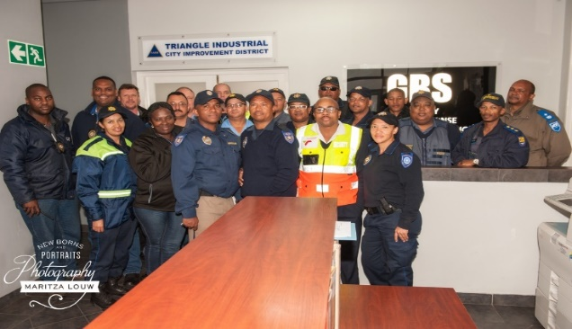

- Due to the increase of robberies on the public open space the mobile trailer donated by DOCS were used effectively and deployed daily in Uranium Street leading to the public open space together with a Public Safety officer.

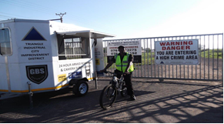

- The CID monitors vacant land belonging to the City of Cape Town and on the Railway reserve reporting any informal structures to the City’s Anti-Land Invasion Unit who promptly attends to this.
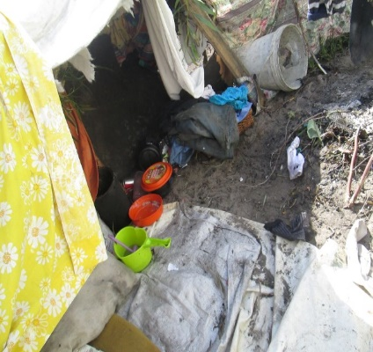
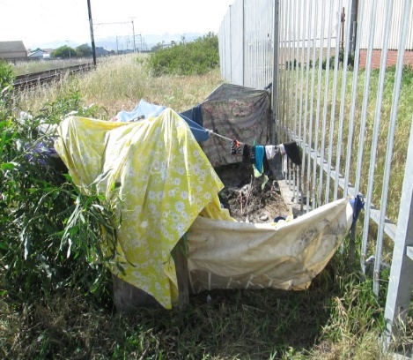

- Distribution of a weekly public safety update and newsletters pertaining to activities occurring in the SRA area.
- Regular updating of the CID’s website at www.trianglefarmcid.co.za incorporating a Home page, Projects, Awareness, Newsletters, and a Business directory of all the companies within the SRA.
- Recycling project to assist and uplift a neighboring school with the assistance of the business associates in the area. With the funds generated from this project, 54 fluorescent lights and four chairs were purchased for the school. This project will also reduce waste to our overloaded landfill sites.
- Surveys were conducted on a regular basis with reports submitted to the City of Cape Town regarding defective street lights, missing drain covers, cleaning/unblocking of drains, maintenance of road surfaces, placing and emptying of litter bins, road markings, road signs, trimming of trees, etc.
- The CID identifies the root causes of grime by conducting necessary surveys and identifying environmental design contributing to grime. A cleansing service is co- ordinated where two cleaners provide a daily “top-up” service to Council, including a garden service that cuts the grass monthly on the public open space and between businesses within the SRA.

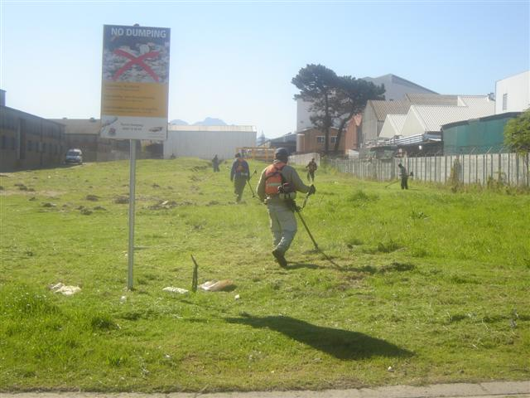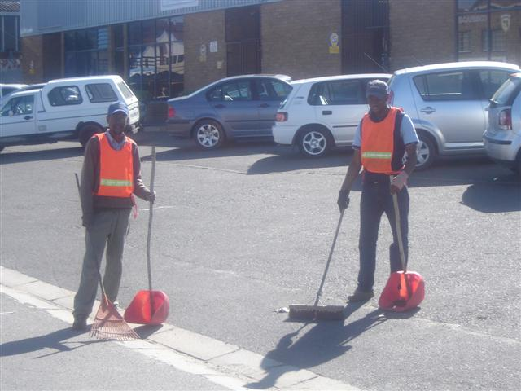
Garden service Cleaners

- Property and business owners are encouraged to keep their premises and street frontages clean. Competitions are held annually for neatest building, best garden and the most improved buildings.

4. PROJECTS / ACHIEVEMENTS

The following projects were successfully completed by the CID:

- Removal of graffiti

Graffiti was noticed on the vibracrete wall leading to the public open space and on a
building in Neutron Street.

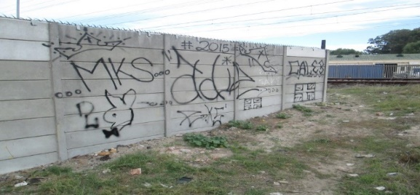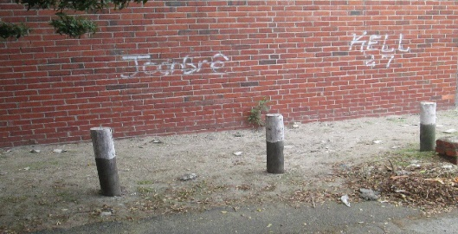

The graffiti was removed by Law Enforcement in October 2016.

- Fire hydrants

A request was submitted to Fire Services and all fire hydrants in Triangle Farm were
serviced in February 2017 which included cleaning, painting and general maintenance.
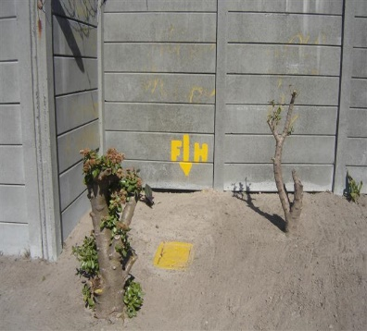

- Media coverage

Media coverage promoting the area and business prospects received attention and an
article was placed in the 28 September 2016 edition of the Tyger Burger.

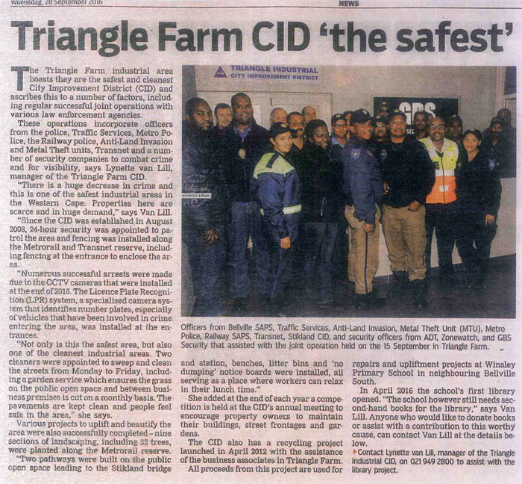

- Bush clearing

Regular requests are submitted to City Parks for the bush clearing on the public open
space (Erf 12698) due to the high fire risk and for the prevention of crime.

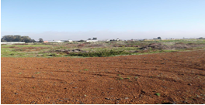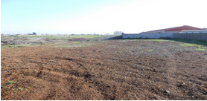

The bush clearing was completed the 10/2016, 12/2016 and 04/2017.

- CCTV Surveillance cameras

The two LPR (License Plate Recognition) cameras at the entrance of Brug and Electron Street was replaced and upgraded with two new Hikvision Edge LPR
cameras in June 2017.

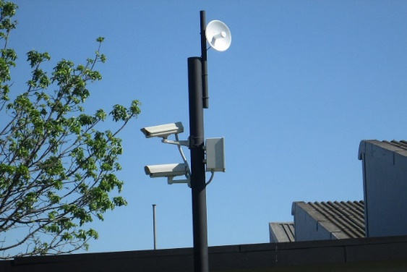

- Roadway on public open space

PPO Infrastructure TDA Cape Town supplied millings for a roadway and levelled the ground on the public open space making it possible for the security to patrol. This was completed in October 2016.

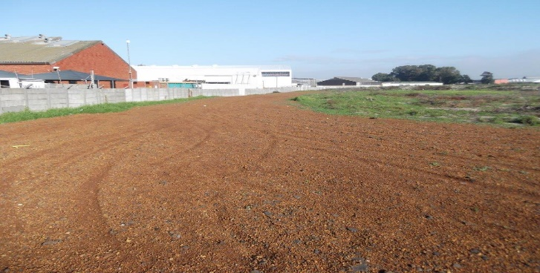

- Public lighting

A request was submitted to the Public lighting department to install lamp poles in Thermo Street due to insufficient lighting.

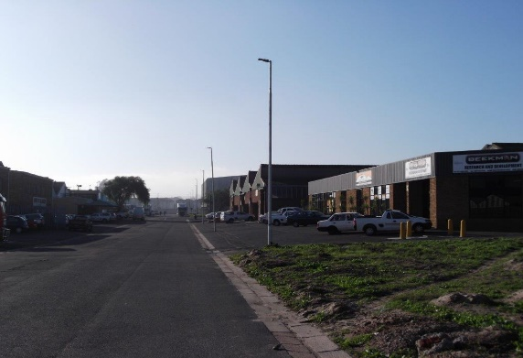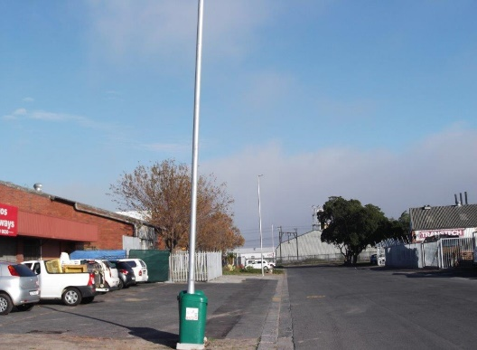

In February 2017 the lamp poles were installed and completed.

- Levelling of parking areas on public open space

The City of Cape Town’s Transport and Urban Development Authority supplied the Triangle Industrial CID with millings for the two parking areas situated in Atomic and Tetra Street.

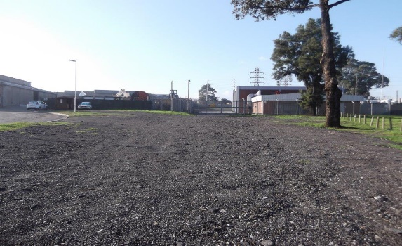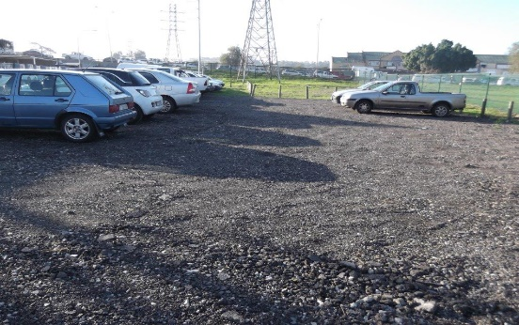
Atomic Street Tetra Street

This was levelled and completed by the CID’s Cleansing service end of May 2017.

The Triangle Industrial CID wishes to extend our most sincere appreciation to the City of Cape Town’s Departments who had rendered excellent service to the CID. Deserving special mention here are:-

- Insp. J. Papier: Law Enforcement
- Capt. G. de Villiers: SAPS Bellville
- Deon Botha: PPO Infrastructure TDA Cape Town
- Dirk Cloete, Bassier Bull: Solid Waste
- Shaun Arrowsmith, Nombini Mafilika: Public Lighting
- Desmond Johnson: Fire Services

5. MEETINGS

In addition to daily meetings with the CID’s Security service provider, the following
meetings also took place during 2016/2017:-

2016-07-06: CID Safety & Security meeting
2016-07-08: CID / SRA Forum Meeting
2016-07-12: Meeting with Antony Marks: Spatial planning & Urban Design
2016-07-12: Meeting with CLC Technologies: CCTV Surveillance
2016-08-15: Meeting with CID Cleansing Service provider
2016-08-16: Meeting with Rubics Solutions: CCTV Surveillance
2016-08-18: CID Board Meeting
2016-08-24: Meeting with Darren Willenberg and Alwyn Muller: SPO: Transport
Network Development
2016-09-07: CID Safety & Security meeting
2016-09-08: Site meeting with Benjamin Steenkamp: City Parks
2016-09-14: Meeting with S. Rigala: City Parks
2016-09-15: CID Joint operation with various role players
2016-09-22: Meeting with CLC Technologies: CCTV Surveillance
2016-09-23: Meeting with Col. Louw (Bellville SAPS)
2016-10-05: CID Safety & Security meeting
2016-10-11: CID Open house Information session re: rehabilitation of Peter Barlow
2016-10-13: CID Board Meeting
2016-11-01: Meeting with Board re: alarms
2016-11-01: Meeting with CLC Technologies: CCTV Surveillance
2016-11-02: CID Safety & Security meeting
2016-11-24: Annual General Meeting
2016-12-16: Winsley Primary Diploma Ceremony
2016-12-08: CID Joint operation with various role players
2017-01-23: Meeting with Desmond Johnson: Fire Services
2017-01-27: Meeting with Principal Winsley Primary re: social project
2017-01-31: Meeting with GBS Security
2017-02-01: CID Safety & Security meeting
2017-02-02: SAPS Sector Forum meeting
2017-02-03: Meeting with CLC Technologies: CCTV Surveillance
2017-02-07: Meeting with Afriwire & Steel re: repair of fence
2017-02-16: CID Board Meeting
2017-02-24: Meeting with CID Cleansing Service provider
2017-02-28: GBS Security meeting
2017-03-01: CID Safety & Security meeting
2017-03-03: Meeting with CID Cleansing Service provider
2017-03-09: Meeting with IP Security Services re: CCTV Surveillance
2017-03-10: Meeting with CID Cleansing Service provider
2017-03-10: Meeting with CID Chairperson and GBS Security
2017-03-14: CID Board Meeting
2017-03-16: Meeting with CID Chairperson and GBS Security
2017-03-17: Meeting with Recycle-It re: recycling project

2017-03-23: CID Joint operation with various role players
2017-03-23: Meeting with Chairperson and GBS Security
2017-03-24: Meeting with CID Cleansing Service provider
2017-03-30: Meeting with GBS Security
2017-04-05: CID Safety & Security meeting
2017-04-12: CID / SRA Forum meeting
2017-04-25: GBS Security meeting
2017-05-03: CID Safety & Security meeting
2017-05-22: NCC Environmental re: cleansing quotation
2017-05-25: CID Board Meeting
2017-05-25: SAPS Bellville CPF Meeting
2017-05-29: Meeting with Recycle-It re: recycling project
2017-06-06: GBS Security meeting
2017-06-07: CID Safety & Security meeting

6. FINANCIAL

The Triangle Industrial City Improvement District NPC currently finds itself in a
sound financial position.

In accordance with the Finance Agreement, the City pays over 97% of the annual
budget to the CID in 1/12th instalments and retains 3% as a provision for bad debts.

Accordingly, the City paid over R1,949,006.00 and retained R60,279.00 for the
2016/17 financial year. Retention of R194,520.02 was refunded to the Triangle
Industrial City Improvement District in 2016/17.

7. NEW MEMBERS / DIRECTORS

During 2016/17 the CID had a total of six directors.

During 2016/17 one application for membership were received. The total
number of members to date is 26.

All directors and existing members are thanked for their commitment towards
the CID’s endeavors.

L. van Lill
Manager
Triangle Industrial City Improvement District NPC
July 2017

