Triangle Industrial  City Improvement District NPC  Company Registration no: 2005/029020/08  VATRegistration no: 4310248457  Busaf Park No. 2 | 30 Bridge Street| Stikland  Tel : 021-949 2800  www.trianglefarmcid.co.za | 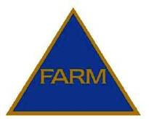

MANAGER / CHAIRMAN’S REPORT

2015/2016

COMPILED BY: LYNETTE VAN LILL
MANAGER
TRIANGLE INDUSTRIAL CITY IMPROVEMENT DISTRICT NPC
JULY 2016

INDEX

- INTRODUCTION

- MISSION / VISION STATEMENTS

- ACTIVITIES

- PROJECTS / ACHIEVEMENTS

- MEETINGS

- FINANCIAL

- NEW MEMBERS / DIRECTORS

Triangle Industrial
City Improvement District NPC
Company Registration no: 2005/029020/08
VATRegistration no: 4310248457
Busaf Park No. 2 | 30 Bridge Street| Stikland
Tel : 021-949 2800
www.trianglefarmcid.co.za

MANAGER / CHAIRMAN’S REPORT: 2015/2016

- INTRODUCTION

The Triangle Industrial City Improvement District (CID) / Special Rating area (SRA)
continuously strives towards building confidence in the area as a safe, attractive and clean environment in which to conduct business with special attention paid to core responsibilities that encourages investment in the area, halt degeneration and promote economic growth/sustainable development.

The CID provides services that are consistent with the City’s Integrated Development Plan (“IDP”) by providing top-up services to the City of Cape Town.

During the period 1 April 2009 to June 2016:-

- 10 493 black bags of litter were removed by the CID’s cleansing service
- 632 151km was travelled in patrols by the CID’s Security provider in the industrial area

The following was reported by the CID to the City of Cape Town:-

- 572 Faulty street lights / damaged lamp poles
- 147 Burst pipes / blocked drains
- 209 Potholes

- MISSION / VISION STATEMENT

The CID has the following mission / vision statements:-

MISSION STATEMENT
To decrease waste and grime and eliminate crime in the Triangle Industrial area through effective security patrols and additional cleansing services and co-ordinating a project aimed at waste minimization.

VISION STATEMENT

Shall strive to develop and market a safe, secure, clean and attractive environment in which to conduct business.

- ACTIVITIES

The CID is managed by a Board of six Directors elected by its members. Services provided focused on safety and security, cleansing initiatives, urban management initiatives, social intervention and marketing.

The Triangle Industrial CID was involved in the following:-

- The CID was instrumental in the co-ordination of Safety and Security meetings that were attended by Management from GBS Security (CID’s Security service provider), SA Police, Traffic Services and various role players. “Hot spot” areas were identified in order to address issues of concern.
- Regular interaction / blitz operations were held incorporating SA Police Service, Traffic Services, and various sections of Specialized services i.e. Metal Theft Unit (MTU), Anti-Land Invasion, including members from various security companies. All role players were thanked for their dedication and valuable input.
- Distribution of a weekly public safety update to tenants and landlords within the SRA.
- Regular updating of the CID’s website at www.trianglefarmcid.co.za incorporating a Home page, Projects, Awareness, Newsletters, and a Business directory of all the companies within the SRA.
- Surveys were conducted on a regular basis with reports submitted to the City of Cape Town regarding defective street lights, missing drain covers, cleaning/unblocking of drains, maintenance of road surfaces, placing and emptying of litter bins, road markings, road signs, trimming of trees, etc.
- The CID monitors vacant land belonging to the City of Cape Town and the Metrorail reserve reporting any informal structures to the City’s Anti-Land Invasion Unit who promptly attends to this.
- The CID identifies the root causes of grime by conducting necessary surveys and identifying environmental design contributing to grime. A cleansing service is co- ordinated where two cleaners provide a daily “top-up” service to Council, including a garden service that cuts the grass monthly on the public open space and between businesses within the SRA.
- Property and business owners are encouraged to keep their premises and street frontages clean. Competitions are held annually for neatest building, best garden and the most improved buildings.

4. PROJECTS / ACHIEVEMENTS

The following projects were successfully completed by the CID:

- Double leaf gate

Due to a servitude in Tetra Street, the CID removed the two existing panels of the Betafence fencing and installed a double leaf gate in July 2015 for the City of Cape Town to gain access to their premises.

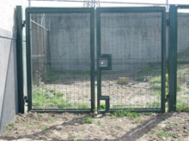

- Social Project

Winsley Primary School was adopted as a social upliftment project. Funds are generated from a recycling project and donations received from business associates within the SRA area. Computers, photocopy machine, books, files were donated to the school. This project has assisted in reducing waste sent to landfill sites.

Jackets were sponsored to the prefects and teachers at the school in July 2015.

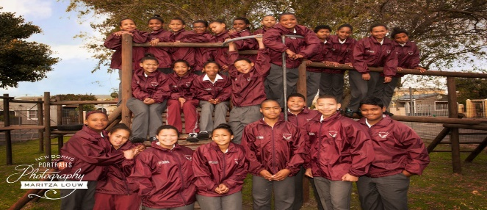

Media coverage promoting the area and business prospects received attention and a promotion page was placed in the 5 August 2015 edition of the Tyger Burger.

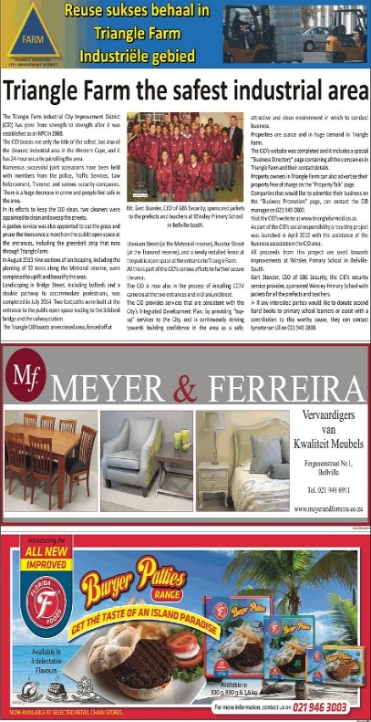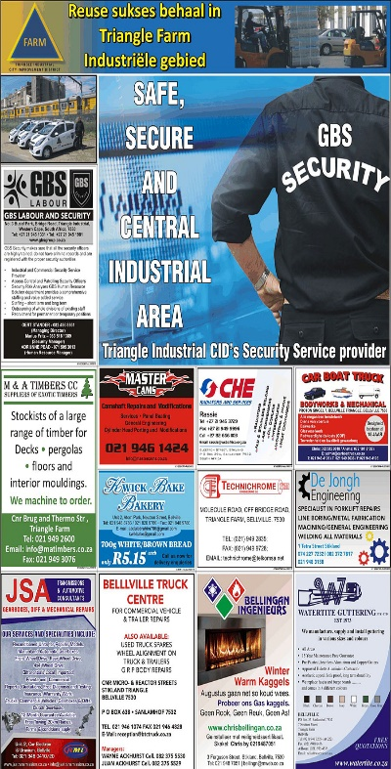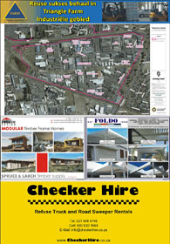

With the funds generated from the recycling project, burglar bars were installed in the
school library.

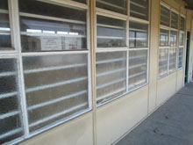

A security gate was sponsored for the library.

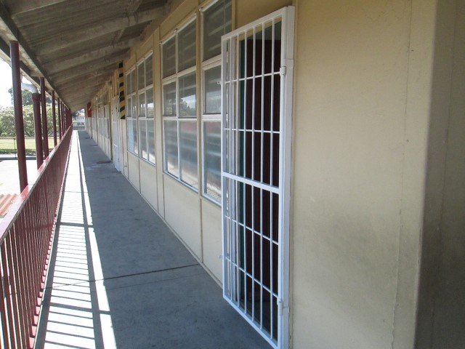

The CID sponsored a board for the entrance of the school and signage was sponsored
by a business associate in the area.

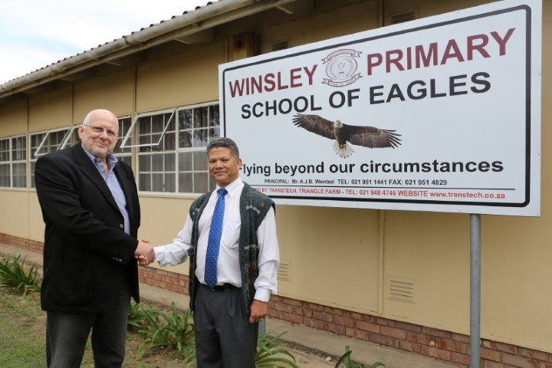

The opening of the school’s library and handing over of the board for the entrance of
the school took place on the 19 April 2016. An article regarding this event including a
promotion page appeared in the 27 April 2016 edition of the Tyger Burger.

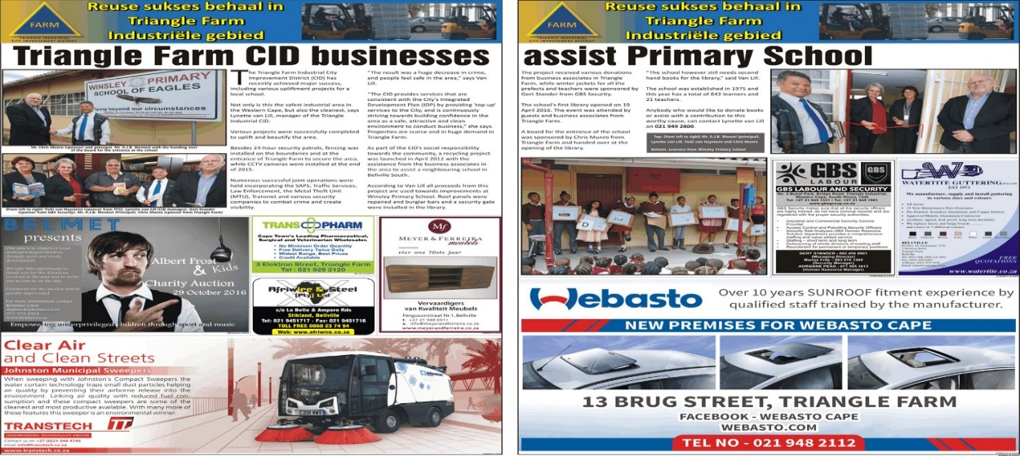

- Bush clearing - (Erf 12698)

A request for bush clearing on the public open space adjacent to Triangle Farm was submitted to City Parks due to the high fire risk and also being a potential hiding place for criminals and attracting squatters to the area. This was completed in August 2015.
Before After
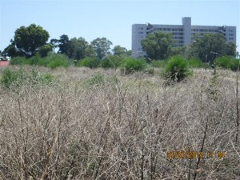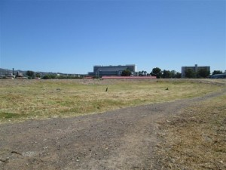

- CCTV Cameras

The Triangle Industrial CID (SRA) installed a total of six cameras in Triangle Farm.

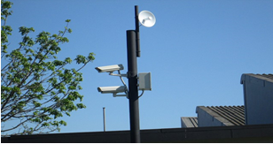

At the two entrances an Overview and LPR (License Plate Recognition Camera), a specialized automated camera system designed for capturing and recognizing vehicle registration numbers was installed. The cameras can be viewed live at the CID and the CID’s Security provider’s office and is monitored by Astrosec in Blackheath.

Media coverage:

The handing over of the cameras took place in September 2015. Media coverage received attention and a Promotion page was placed in the 30 September 2015 edition of the Tyger Burger.

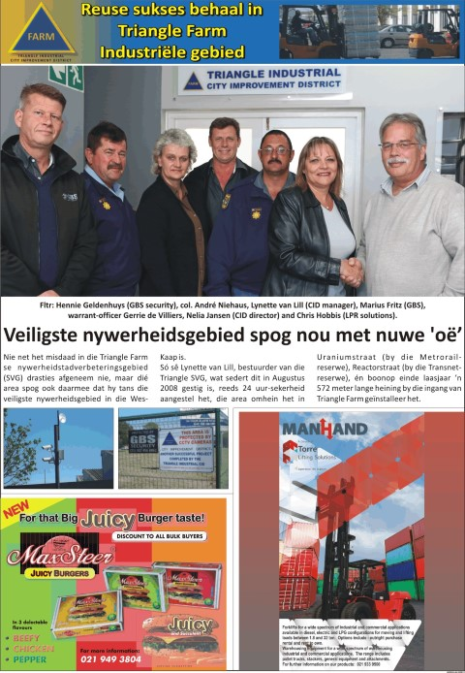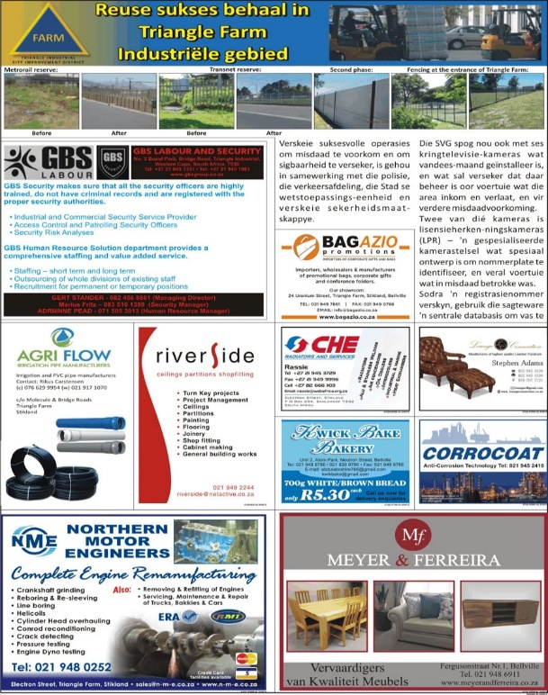

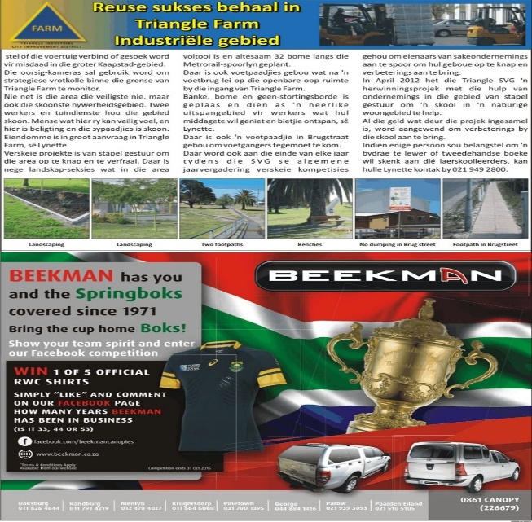

The CID would like to thank the companies in Triangle Farm for placing advertisements in the CID’s Promotion page.

- Pathway – Bridge Street

New pathways were built on the public open space at the entrance of Triangle Farm in Bridge Street to accommodate the huge volumes of pedestrians. This was completed in October 2015.

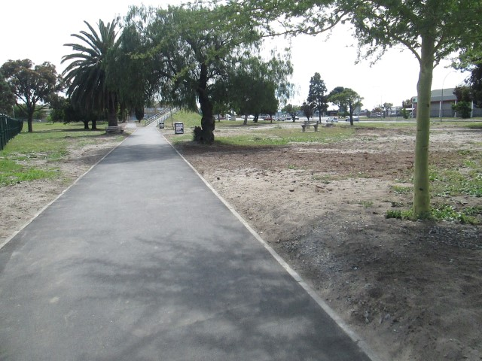

- Public Lighting

A request was submitted to the Public Lighting department to install lamp poles next to the pathways on the public open space at the entrance of Bridge Street and on the opposite side of the road next to the BP garage. This was completed in November 2015.

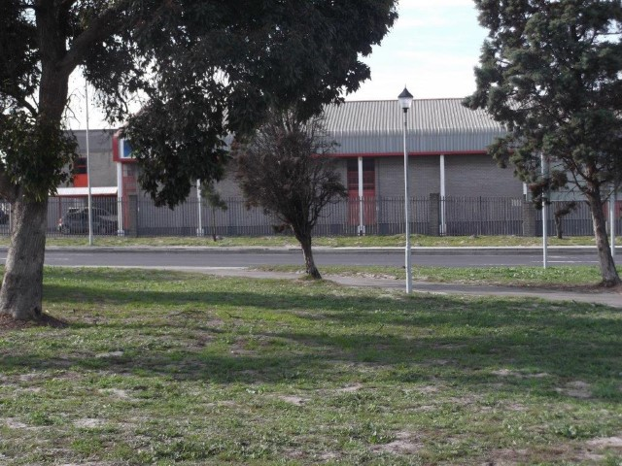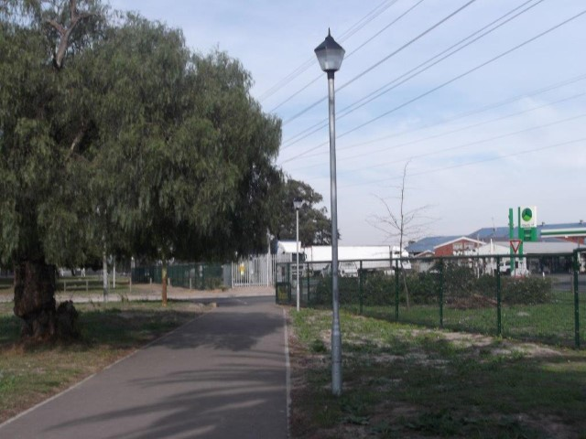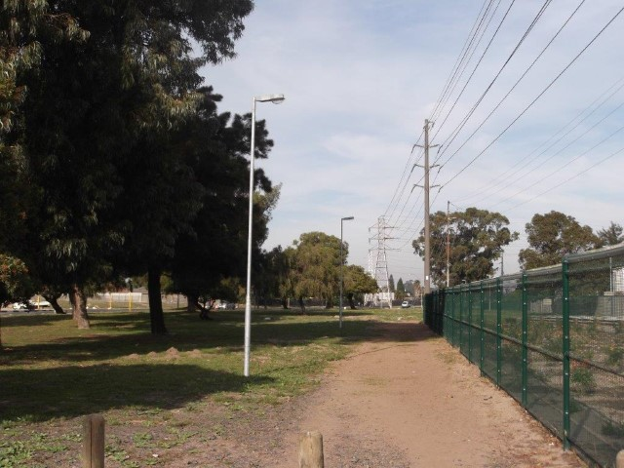

- Painting of street names, barrier lines, etc.

A request was submitted to TCT Transport to paint all the street names, barrier lines,
stop and yield signs in the area. This was completed in October 2015.

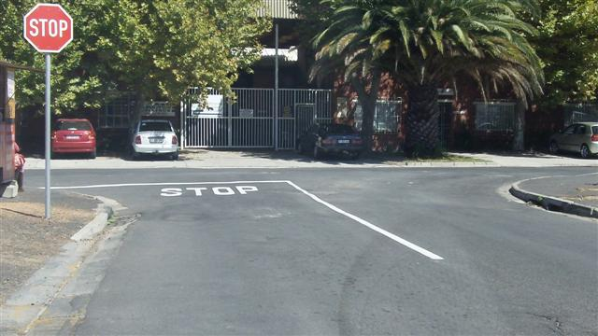

- Bush clearing along the Metrorail reserve

Due to the high fire risk and a potential hiding place for criminals the bush clearing along the Metrorail reserve was done in October 2015 and again in May 2016.

Before After
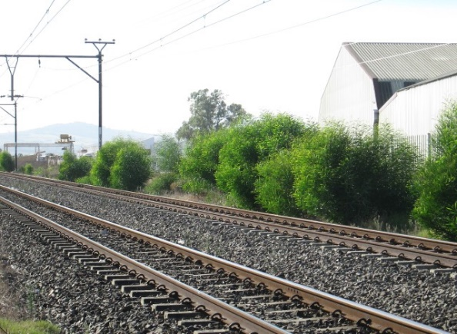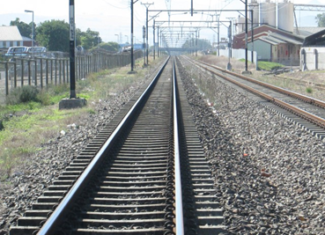

- Tarring - Molecule Street

Due to the roots causing damage to the paving in Molecule Street, the CID submitted a request to City Parks.
Before
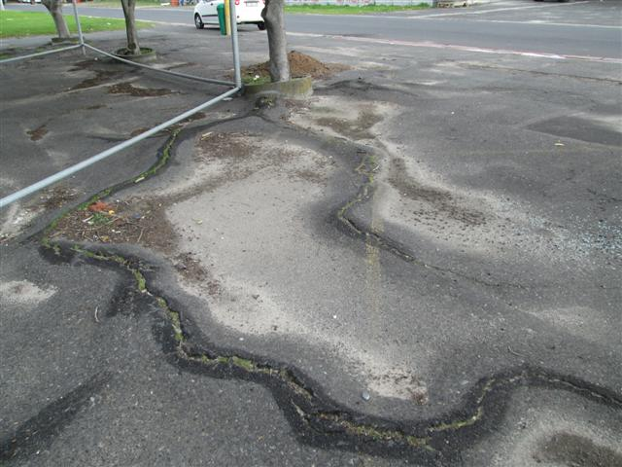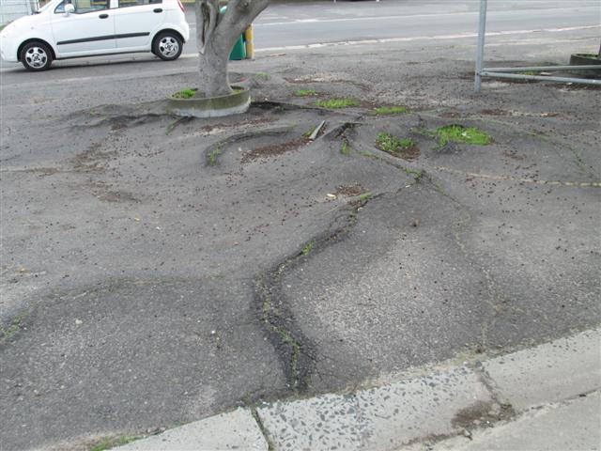

Root pruning
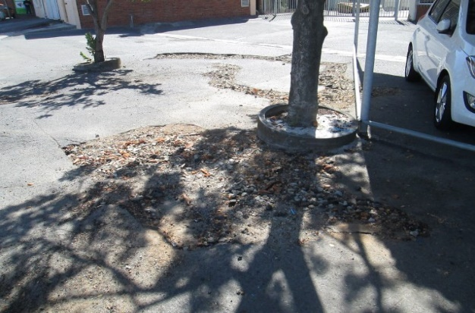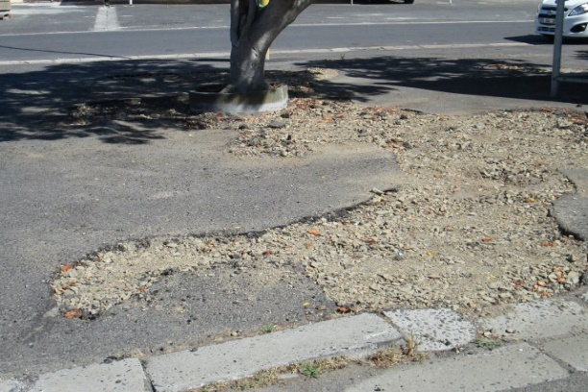

Tarring was completed in November 2015
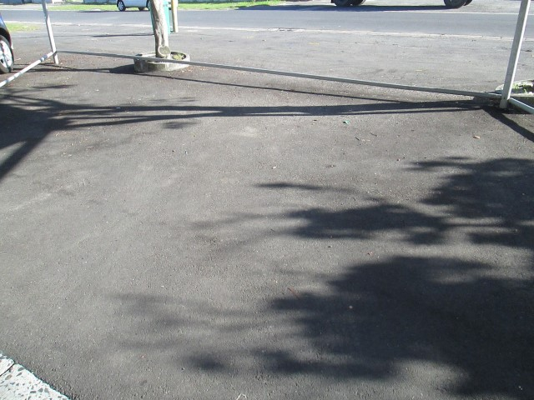

- Bus stop signage

An investigation was done after complaints were received regarding busses stopping in the middle of the road to load and offload pedestrians. It was observed that Golden Arrow busses are operating in the Triangle Farm area.

A request was submitted to Public Transport Infrastructure Planning & Design to investigate and find a safe area for the busses to stop, and to implement signage and road markings.

A Bus stop signage was installed in Bridge Street in the parking area in front of DPI Plastics.

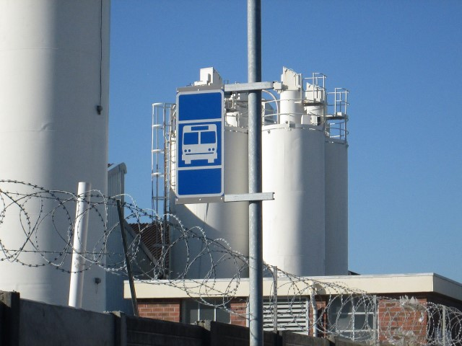

However, trucks are still parking in the parking area designated for busses to stop. The CID has submitted a further request for clear and visible road markings.

- “Warning” board

Due to the armed robberies taking place on the public open space leading from Uranium Street, the CID installed a “Warning” board on the gate informing this is
a high crime area and an alternative route must be taken. The board has been placed alongside the CID’s Security provider’s “emergency” numbers.

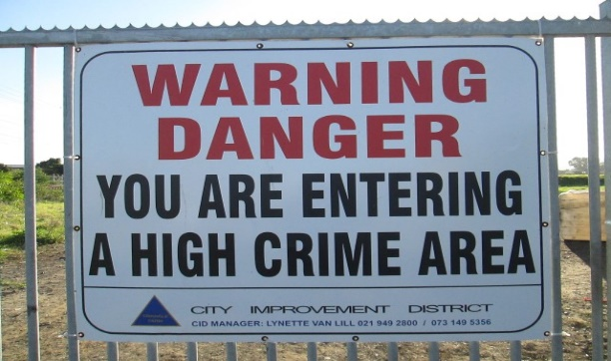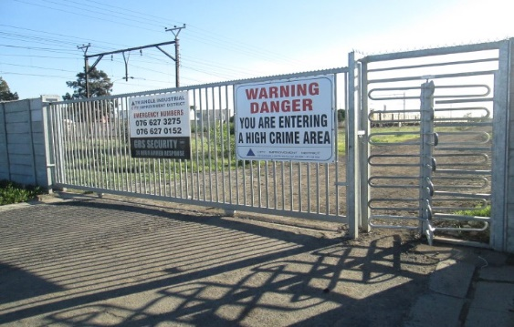

- Boards – CCTV cameras

Four boards were installed at the two entrances informing the area is protected by CCTV cameras.

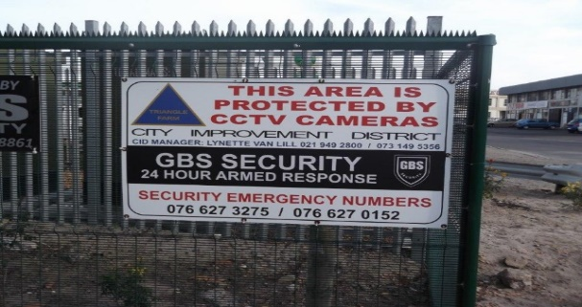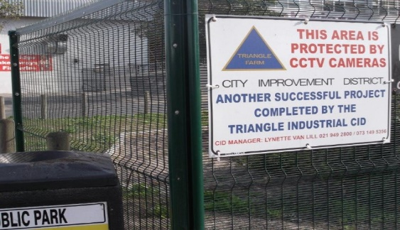

- Landscaping

Landscaping on the public open space at the entrance of Bridge Street to uplift and beautify the area was completed in May 2016.

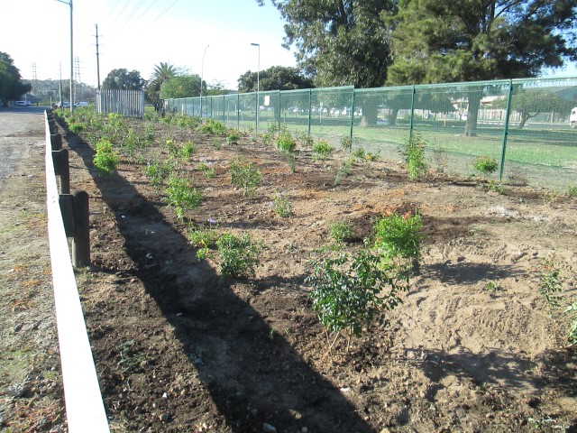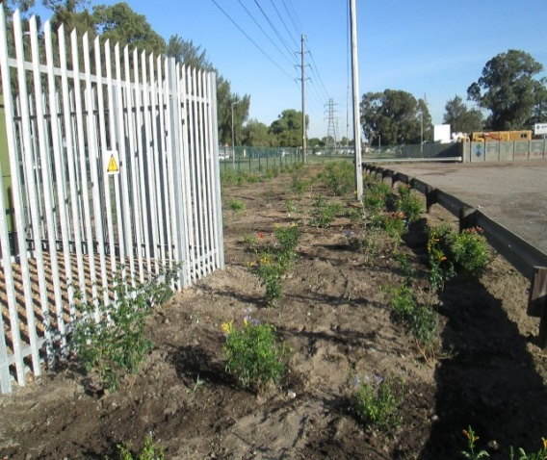

The Triangle Industrial CID wishes to extend our most sincere appreciation to the City of Cape Town’s Departments who had rendered excellent service to the CID. Deserving special mention here are:-

- Anti-Land Invasion Unit (Insp. J. Papier)
- Traffic Services (P/Insp. D. Benadie)
- SA Police Service (Capt. G. de Villiers)
- Norma Lucas (City Parks)
- Jay-Dee Bruce and Niklaas van Schalkwyk (TCT Transport)
- Bassier Bull (Solid Waste)
- Shaun Arrowsmith, Nombini Mafilika (Public Lighting)

5. MEETINGS

In addition to daily meetings with the CID’s Security service provider, the following
meetings also took place during 2015/2016:-

2015-07-01: CID Safety & Security meeting
2015-07-03: CID Joint operation incorporating SA Police Service, Traffic Services,
Specialized Services, etc.
2015-07-07: TCT Transport re: tarring in Electron Str.
2015-07-07: Bernard’s Steel Art re: repair of turnstile in Uranium Str.
2015-07-13: Meeting Brig. van Dyk – New Station Commander SAPS Bellville
2015-07-20: Meeting Afriwire & Steel – sponsor for CID boards
2015-07-21: Meeting with LPR Solutions re: CID’s CCTV cameras
2015-07-21: Meeting with CID’s Cleansing Service provider
2015-07-21: Meeting with Media re: CID’s Promotion page
2015-07-23: Meeting with Capt. F. Nimb SAPS Bellville
2015-07-29: Social project: Handing over of jackets (sponsor) for prefects at
Winsley Primary School, Bellville-South / Media
2015-08-05: CID Safety & Security meeting
2015-08-05: Promotion page in the Tyger Burger re: the CID’s social project -
recycling project and sponsor.
2015-08-13: Meeting with principal re: burglar bars / security gate for school
library
2015-08-18: Special Rating Area (SRA) Forum Meeting
2015-08-19: Meeting Col. Vorsatz – Station Commander Bellville-South
2015-08-20: CID Board meeting
2015-08-26: Bellville-South CPF Meeting
2015-09-02: CID Safety & Security meeting
2015-09-03: Meeting with Public Lighting re: lamp poles on public open space at
the entrance of Bridge Str.
2015-09-11: Handing over of CID’s CCTV cameras and Media
2015-09-17: Public Transport Infrastructure re: bus stop signage in Bridge Street
2015-09-28: Meeting with Astrosec (CID’s CCTV Monitoring company) and LPR
Solutions

2015-10-07: CID Safety & Security meeting
2015-10-12: Meeting with Entity Sheet Metal Works re: security cage for cameras
2015-10-13: CID Board meeting
2015-10-13: Meeting with Public Lighting and contractors (pathway) re: cable
ducts on public open space
2015-10-21: Meeting with Astrosec, LPR Solutions, CID Director and GBS
Security re: CID’s CCTV cameras
2015-11-03: TCT Transport re: water channel on the corner of Uranium &
Molecule Str.
2015-11-04: CID Safety & Security meeting
2015-11-12: CID Board meeting
2015-11-26: CID Annual General Meeting
2015-12-04: Meeting with Astrosec, LPR Solutions, CID Director and GBS
Security re: CID’s CCTV cameras
2015-12-08: TCT Transport site meeting re: water channel – corner Uranium &
Molecule Str.
2015-12-08: Meeting with CCTV monitoring company in Blackheath
2016-01-14: Meeting with CID Chairman, Director re: CCTV cameras
2016-01-15: Meeting with LPR Solutions re: CCTV cameras
2016-01-16: Meeting with CID Chairman, City Parks, Sector Manager SAPS
Bellville re: robberies taking place on the public open space
2016-02-03: CID Safety & Security meeting
2016-02-03: Meeting Kontrasigns re: board for entrance of school
2016-02-11: Meeting with CID Chairman, Director, Astrosec and LPR Solutions
re: CCTV cameras
2016-02-11: CID Board meeting
2016-02-29: Meeting with contractors for pathway re: repair of irrigation system
on the public open space at the entrance of Bridge Str.
2016-03-02: CID Safety & Security meeting
2016-03-02: TCT Transport re: water channel – Cnr. Uranium & Molecule Str.
2016-03-03: Bellville SAPS Planning meeting
2016-03-03: SAPS Clearance certificate
2016-03-10: SAPS Planning meeting
2016-04-05: CID Safety & Security meeting
2016-04-06: Special Rating Area (SRA) Forum meeting
2016-04-07: Executive Risk Solutions re: CCTV cameras
2016-04-07: SAPS Planning meeting
2016-04-13: Meeting with Waste Plan re: CID’s Recyling project
2016-04-14: SAPS Planning meeting
2016-04-15: CID Joint operation with role players
2016-04-19: Opening of Winsley Primary School’s first library and handing over
of board for entrance of school / including Media
2016-04-21: Meeting with Waste Plan
2016-05-04: CID Safety & Security meeting
2016-05-09: Meeting with CID Cleansing Service provider
2016-05-12: CID Board meeting
2016-05-12: Meeting with Waste Plan re: Recycling project
2016-05-31: Meeting with OWL Management Consultants re: CCTV cameras
2016-06-01: CID Safety & Security meeting
2016-06-27: Meeting with CCTV monitoring company
2016-06-28: Meeting with Fang re: CCTV cameras
2016-06-29: Meeting with Rubics Solutions re: CCTV cameras
2016-06-30: Meeting with Megapixel re: CCTV cameras

6. FINANCIAL

The Triangle Industrial City Improvement District NPC currently finds itself in a
sound financial position.

In accordance with the Finance Agreement that exists between Triangle
Industrial City Improvement District and the City of Cape Town (COCT), the
City pays over 97% of the annual budget to the CID/SRA in 1/12th instalments
and retains 3% as a provision for bad debts.

Accordingly the City paid over R1,833,792.00 and retained R56,715.00 for the
2015/16 financial year. Retention of R83,298.69 was refunded to Triangle
Industrial City Improvement District NPC in 2015/16.

7. NEW MEMBERS / DIRECTORS

During 2015/16 the CID had a total of six directors.

During 2015/16 one member ceased to be a member and two applications for
membership were received. The total number of members to date is 25.

All directors and existing members are thanked for their commitment towards
the CID’s endeavors.

L. van Lill
Manager
Triangle Industrial City Improvement District NPC
July 2016

